**Assignment -1**

Digital Marketing

|  |  |
| --- | --- |
| Student Name | Angel P |
| Student Roll Number | 20URCS004 |
| NM ID | A73DA3A38A9850BBE054E48B3B0E06EB |
| College Name | AAA College of Engineering and Technology |

**QUESTION:**

**Create a blog or website using Blogspot and WordPress. Customize the theme design and post new article with 500 words.**

**BLOG USING BLOGSPOT:**

**Blog link:** <https://rosebuds013.blogspot.com/2023/08/rose-buds.html>

**Blog Title: Rose Buds – Baby Shop**

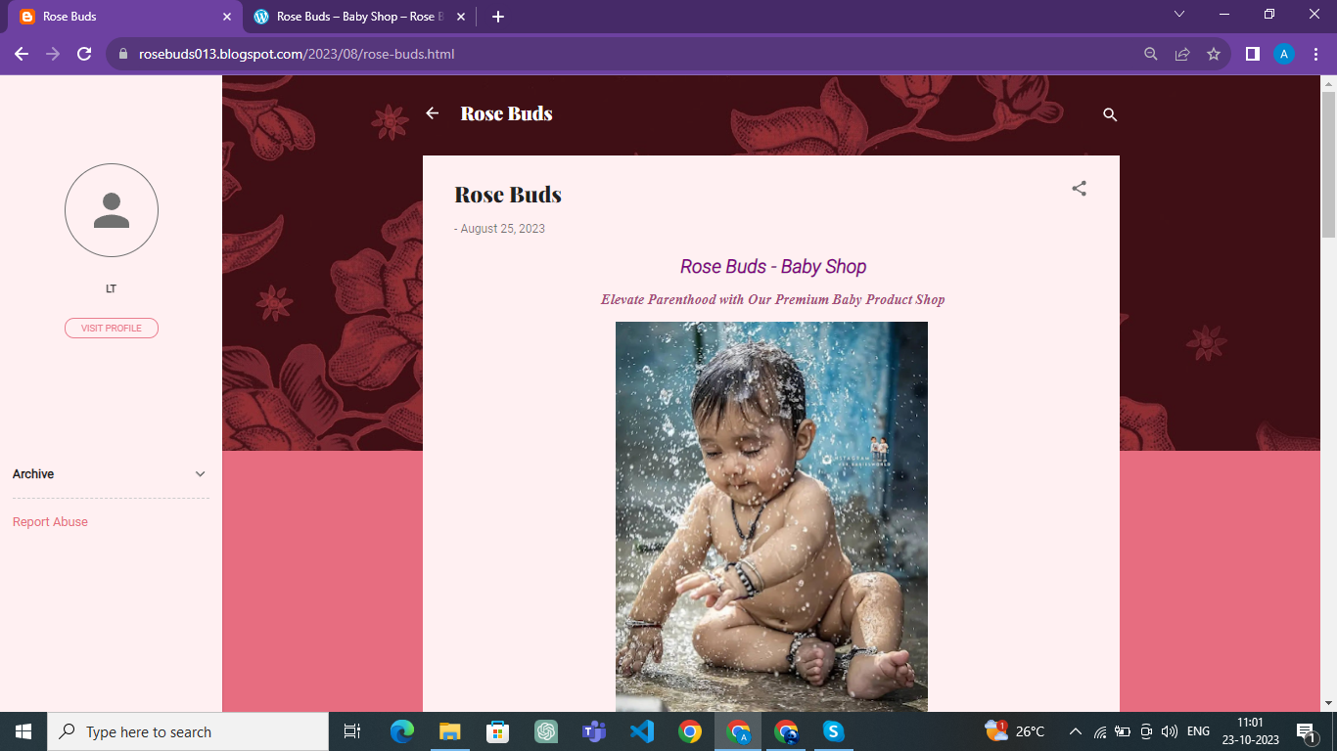

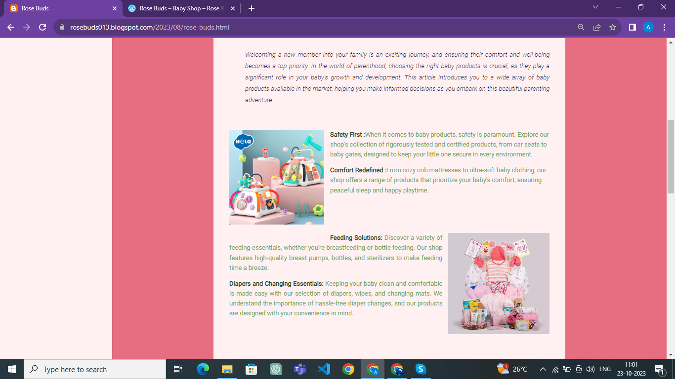

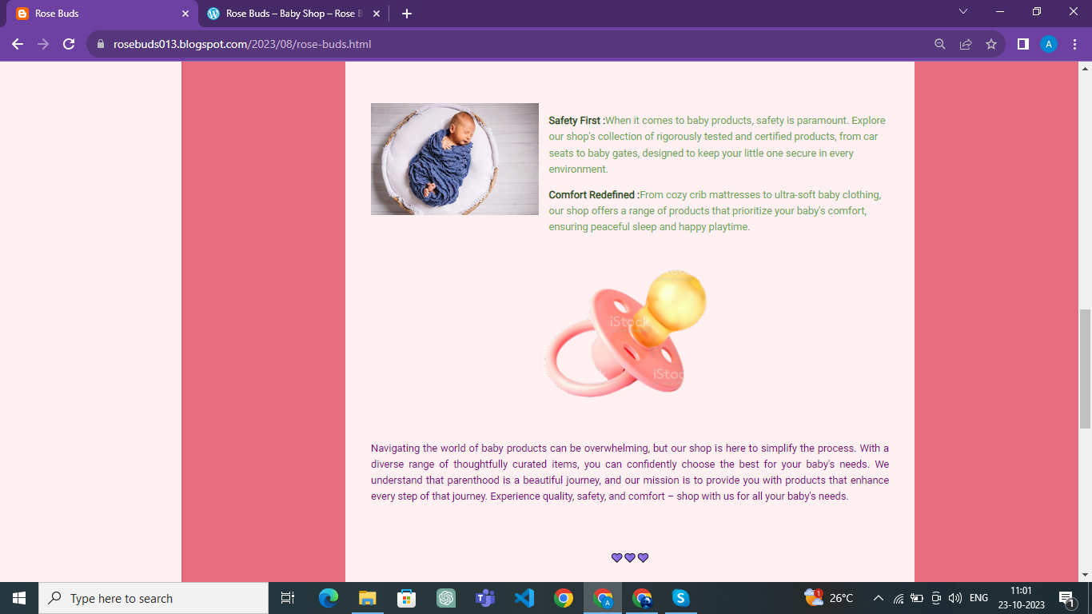

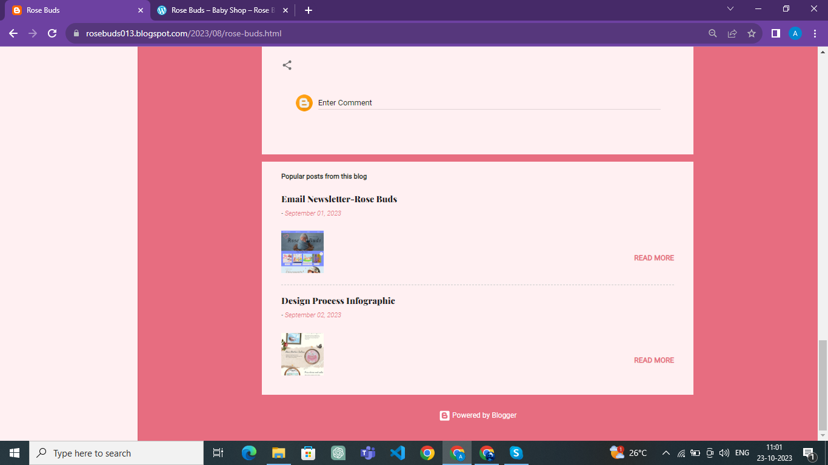

**BLOG USING WORDPRESS:**

**Wordpress link:** <https://20urcs004.wordpress.com/2023/10/22/rose-buds-baby-shop/>

**Blog Title: Rose Buds – Baby Shop**

